Job Description
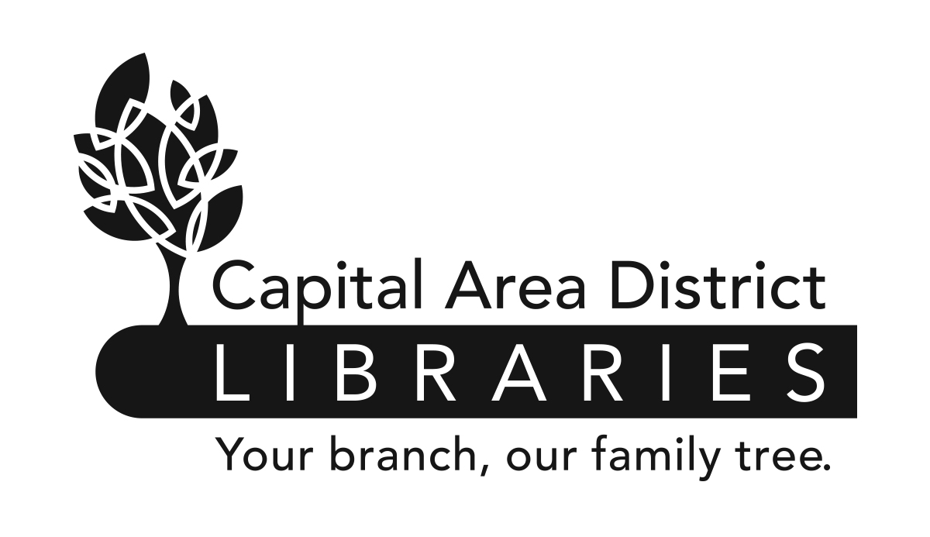

Position: | Mobile Library Assistant
Range: | T4 (Non-Exempt) (Union)
Reports to: | Head of Community Outreach
Supervises: | None
Reviewed: | 3/26
Revised:

www.cadl.org

Job Summary

Under the supervision of the Head of Community Outreach, the position provides mobile library services to patrons of all ages. These services include Readers Advisory, instruction in basic technology, troubleshooting digital services and programing for Youth and Adults. In addition, the position helps to maintain the mobile library’s collection and performs a variety of circulation functions. Ability to workdays, nights, and weekends. Regular Saturday work is required.
Duties and Responsibilities

- Provides excellent, friendly and user centered service to people seeking library services.
- Provides readers advisory services and stays up to date on reading and publishing trends.
- Assists at the mobile library Circulation desk, checking out material and registering patrons for library cards.
- Instructs and assists patrons in basic technology support and troubleshooting of digital services and resources.
- Assists in planning and organizing library programs for the community. Plans, prepares and implements programing for patrons of all ages. Direct and/or implements special projects involving library promotion and outreach activities.
- Assists in preparing and setting up displays, exhibits, and bulletin boards to maintain an informative and attractive setting on the mobile library.
- Helps in shelving library materials and maintains the mobile library as needed. Maintain security, ensuring windows and doors are locked at the end of the day. Clean the vehicle on a regular basis.
- Help patrons in boarding and exiting the mobile library.
- Will be required to drive the mobile library or delivery van as needed.
- Performs basic inspection and maintenance of the vehicle to ensure proper maintenance, including keeping the fuel tank and various automotive fluids filled.
- Other duties as assigned.
The above statements are intended to describe the general nature and level of work being performed by people assigned this classification. They are not to be construed as an exhaustive list of all job duties performed by personnel so classified.

Job Requirements

- Possession of a Bachelor’s Degree or its equivalent.
- Possession of a Chauffeur’s License
- A valid Michigan Driver’s License, and an acceptable driving record. Must maintain acceptable level of insurance coverage.
- This is an entry-level classification; no previous experience is required. Experience working in a public library is preferred.
- Satisfactory completion of a six-month probationary period.
- Be physically able to perform the essential functions of the job with or without reasonable accommodation.
- Ability to lift 50 lb. boxes and assist patrons with physical needs
- Must be able to rapidly and repeatedly climb and descend steps of mobile library.
- Requires the ability to reach and grasp materials located in all areas of the mobile library
- The ability to load/unload materials and equipment.

- The ability to travel daily around the community in all kinds of weather, climatic conditions and at night.
- Second Language speakers desired (Nepali, Arabic, Spanish, Hmong/Lao, and Hindi)
- Knowledge of library organization, materials, services, and policies and procedures.
- Knowledge of the principles and methods of evaluating library materials and equipment.
- Ability to use computers and to utilize computer databases.
- Effective written and oral communication skills.
- Ability to establish and maintain effective working relationships with co-workers, and the public.
- Ability to conduct oneself with tact and courtesy.

Library Assistant Job Description
Page 2 of 2

